Puerto Rican food is very dependent on Plantains, as they can be found growing all over the island, and need very little to grow other than the sunshine and rain of Puerto Rico. Plantains are a banana like food that are technically classified as a fruit. Fried plantains are used in many dishes in Puerto Rico, such as Mofongo, and Tostones.

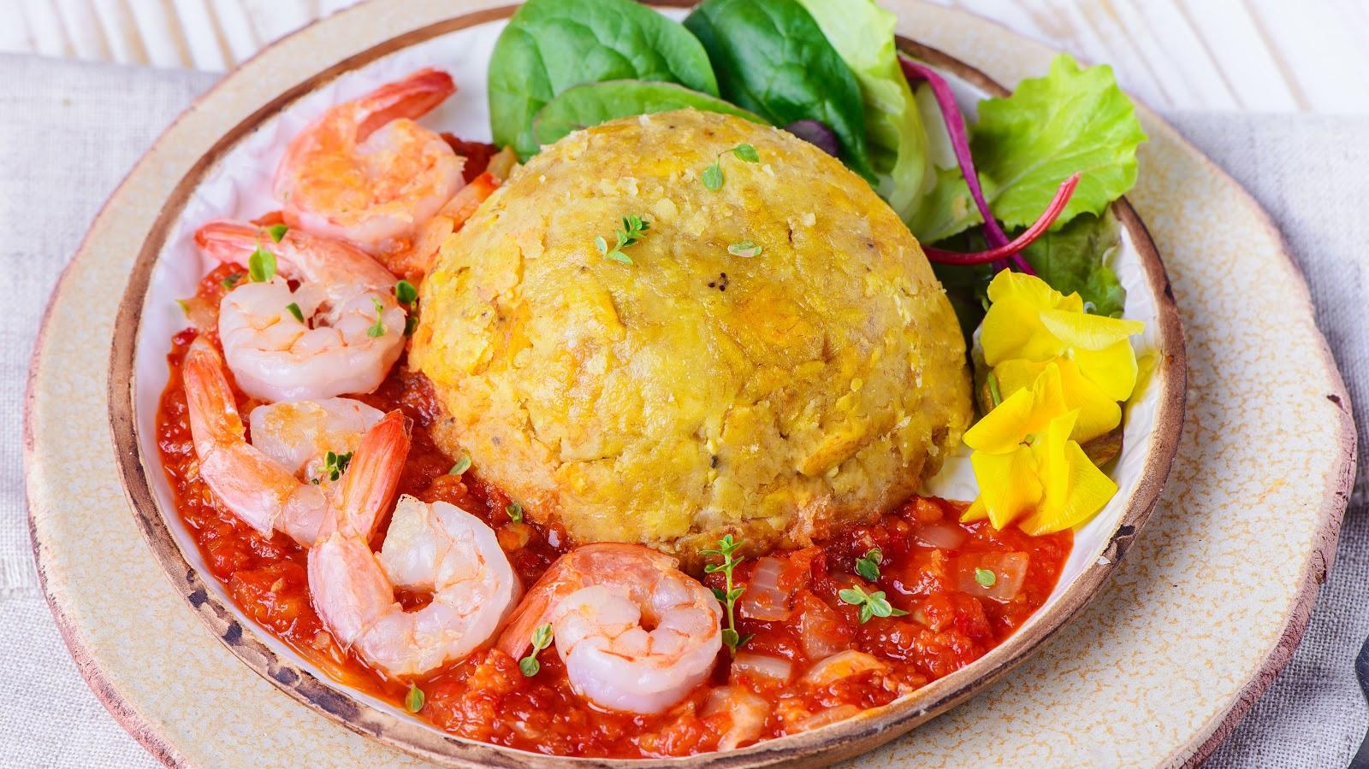

Mofongo- Fried Plantains, then mashed with garlic and salt into a mash, typically eaten with fish or shellfish.

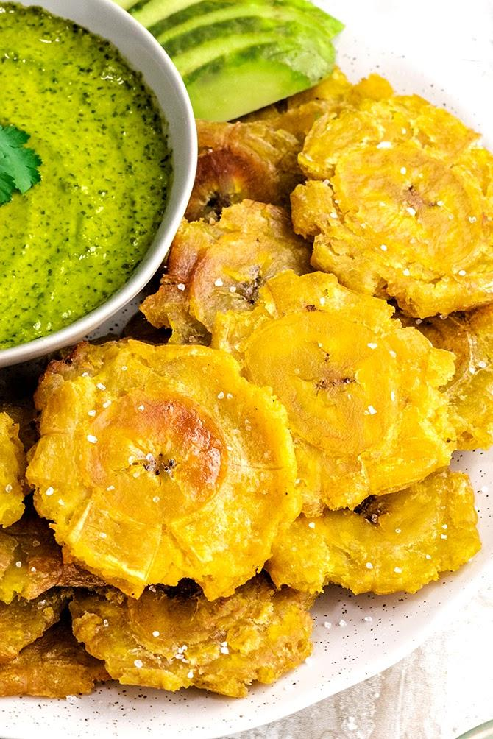

Tostones- Twice fried plantains made by pressing plantains into a flat shape with salt or olive oil.